UMGC DATA 620 Assignment 1.3

**Name: Melissa Hunfalvay**

**Part 4 – Single Table Queries**

This is where you start to turn things in. To turn in your assignment, delete the preceding pages and start with this one. Make sure to put your name up top.

Construct SQL to answer each of the following questions. For each query, paste your SQL code below, and also paste a screenshot of the first 10 or so rows the query gives you.

Give an answer to the question based only on what you see in your MySQL database. (Do not use Excel or other tools to answer these questions; since we are trying to learn MySQL here, you should do these exercises in MySQL.)

You will eventually submit this document as part of your week’s homework.

After you have completed your first draft of this document, you will use the online quiz to verify your answers. The online quiz uses the same numbering system given here, so you can quickly find the question you need.

You are welcome to update your homework document with results from the online quiz, and submit the homework document after you’ve checked your homework online.

The first question has been done for you as an example. Note the example database may or may not contain the same information as yours.

1. [SQL Week 1 Question 100-001] SELECT just the Name and Gender columns from litcharacters. Order ascending by idLitCharacters (you may display the idLitCharacters if you like but it is not required. You need to sort by that field.)

SELECT Name, Gender FROM litcharacters ORDER BY idLitCharacters;

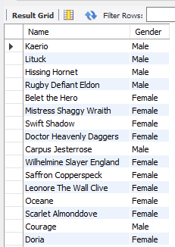

1. [SQL Week 1 Question 100-002] List the different creature types are there in the litcharacters database? For example, if you had three humans and one animal, that would be two types – human and animal.

SELECT DISTINCT CreatureType FROM masterpiece.litcharacters;

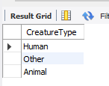

1. [SQL Week 1 Question 100-003] Make output which includes only the Name, Creature Type, and Creature SubType for all the Animals. Order by ascending idLitCharacters (you may display the idLitCharacters if you like but it is not required. Whether or not you display the idLitCharacters field, you need to sort by it.)

SELECT name,creaturetype,creaturesubtype FROM masterpiece.litcharacters ORDER BY idLitCharacters ASC;

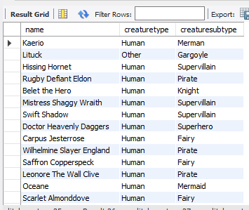

1. [SQL Week 1 Question 100-004] Your editor wants a list of the Name, Creature Type, Creature SubType and Gender for all new creatures – those who have not made an appearance yet (so their Appearance total is 0.) Order by ascending idLitCharacters (you may display the idLitCharacters if you like but it is not required. Whether or not you display the idLitCharacters field, you need to sort by it.)

SELECT name,creaturetype,creaturesubtype,gender FROM masterpiece.litcharacters WHERE Appearances=0 ORDER BY idLitCharacters ASC;

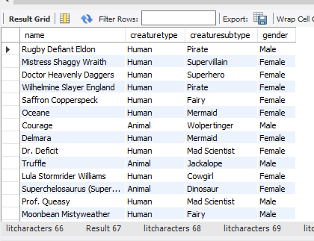

1. [SQL Week 1 Question 100-005]

Now your editor wants a list of the Name, Creature Type, Creature SubType and Gender for all well-worn creatures – those who have made 5 or more appearances. Include those who have made exactly 5 appearances. Order by ascending idLitCharacters.

SELECT name,creaturetype,creaturesubtype,gender FROM masterpiece.litcharacters WHERE Appearances>=5 ORDER BY idLitCharacters ASC;

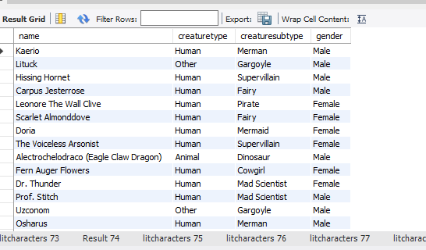

1. [SQL Week 1 Question 100-006] They want to know the mid-popular ones as well. Create a list of the Name, Creature Type, Creature SubType and Gender for all mid-popular creatures - those who have made between 3 and 5 appearances. Include those who have made exactly 3 and exactly 5 appearances. Order by ascending idLitCharacters.

SELECT name,creaturetype,creaturesubtype,gender FROM masterpiece.litcharacters WHERE Appearances BETWEEN 3 AND 5 ORDER BY idLitCharacters ASC;

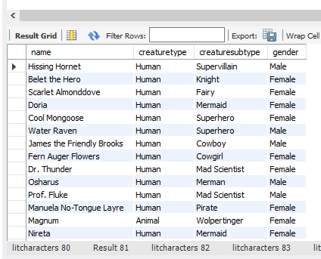

1. [SQL Week 1 Question 100-007] Get a listing of the id number (idLitCharacters), Name, Creature SubType for all the pirates, mermaids, and fairies. Only include these three Subtypes. Order by ascending idLitCharacters.

select idLitcharacters,name,creaturetype,creaturesubtype FROM masterpiece.litcharacters WHERE creaturesubtype IN('pirate','mermaid','fairy')ORDER BY idLitCharacters ASC;

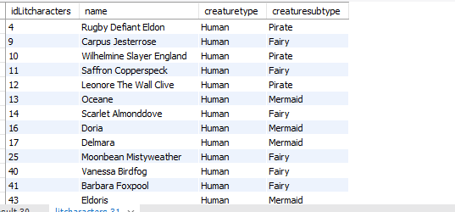

1. [SQL Week 1 Question 100-008] You need a big scary one. Get a listing of all the names of Basilisks which have a weight greater than 475. Make sure you print the ID, the name, the Creature SubType, and the weight. Order by ascending idLitCharacters.

select idLitcharacters,name,creaturetype,creaturesubtype,weight FROM masterpiece.litcharacters WHERE creaturesubtype='Basilisk' AND weight> 475 ORDER BY idLitCharacters ASC;

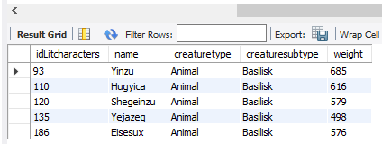

1. [SQL Week 1 Question 100-009] You want to get some name ideas for somebody who is either a mad scientist or supervillain. What are those names? Print out the Lit Character ID as well as the name and Sub Type. Order by ascending idLitCharacters.

select idLitcharacters,name,creaturetype,creaturesubtype FROM masterpiece.litcharacters WHERE creaturesubtype='Mad Scientist' OR creaturesubtype='supervillain' ORDER BY idLitCharacters ASC;

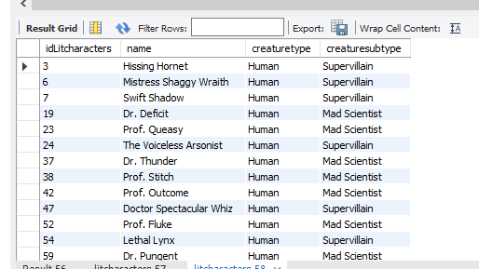

1. [SQL Week 1 Question 100-010] You need a list of non-male creatures. Select the idLitCharacter, Name, Creature SubType, and Gender for everybody whose gender is not designated as Male. Order by ascending idLitCharacters. Take a screenshot of the top of your output. Then scroll down until you see ID 51, Amara the Mermaid. Take a screenshot of Amara and the rows immediately beneath her as well.

select idLitcharacters,name,creaturetype,creaturesubtype,gender FROM masterpiece.litcharacters WHERE NOT gender='male' ORDER BY idLitCharacters ASC;

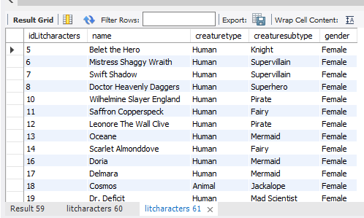

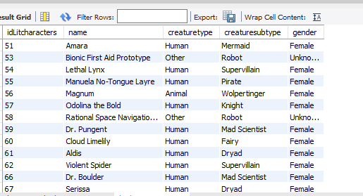

1. [SQL Week 1 Question 100-011] Select the idLitCharacters, name, Gender, Creature SubType. Your newest author wants a specific list of names which meet one of two criteria. The first criteria to meet would be a female pirate. The second criteria to meet would be any cute tiny male creature of weight 10 or below. Your output should contain some female pirates and some cute tiny male creatures. Sort the results first alphabetically on Gender and then within that field by idLitCharacters ascending.

select idLitcharacters,name,creaturetype,creaturesubtype,gender,weight FROM masterpiece.litcharacters WHERE (gender='female' AND creaturesubtype= 'pirate') OR (gender= 'male' AND weight<=10) ORDER BY gender, idLitCharacters ASC;

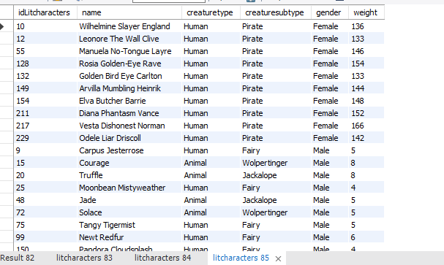

1. [SQL Week 1 Question 100-012] Display the idLitCharacters, name, Gender, Creature SubType, weight, and height for everybody whose height is greater than or equal to 200. Sort it so the heaviest ones are on the top, and within the weight then ascending by idLitCharacters.

select idLitcharacters,name,gender,creaturesubtype,weight,height FROM masterpiece.litcharacters WHERE height>= 200 ORDER BY weight DESC, idLitCharacters ASC;

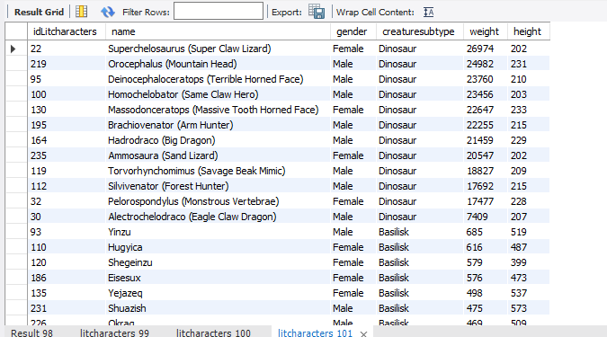

1. [SQL Week 1 Question 100-013] You want the big ones. Make a list of all the ID, the name, the Creature SubType, and weight and height. You only want those whose weight is greater than or equal to 150 or those whose height is greater than or equal to 65. Sort your results alphabetically by Name and then ascending by idLitCharacter.

select idLitcharacters,name,creaturesubtype,weight,height FROM masterpiece.litcharacters WHERE weight>= 150 OR height>=65 ORDER BY name, idLitCharacters ASC;

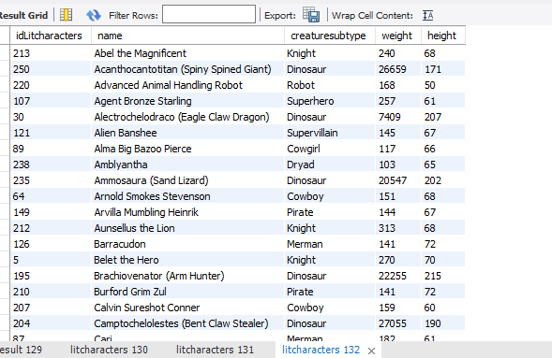

1. [SQL Week 1 Question 100-014] You want to know for all humans whose realm is Magical, what is the maximum weight in pounds?

Select MAX(weight) FROM masterpiece.litcharacters WHERE realm = "Magical";

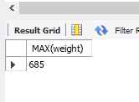

1. [SQL Week 1 Question 100-015] What is the lightest weight of any of the creatures who is taller than 60 inches?

Select MIN(weight) FROM masterpiece.litcharacters WHERE height> 60;

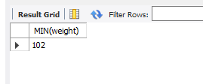

1. [SQL Week 1 Question 100-016] How many creatures are of type Human?

Select COUNT(CreatureType) FROM masterpiece.litcharacters Where creaturetype= 'human';

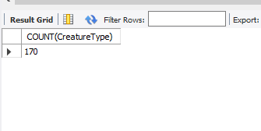

1. [SQL Week 1 Question 100-017] Get the average weight of all human type creatures. Note your answer to four decimal places.

Select AVG(weight) FROM masterpiece.litcharacters Where creaturetype= 'human';

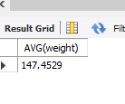

1. [SQL Week 1 Question 100-018] Your newest novel has a scene in which all the miscreants are on a bridge, but collectively they are too heavy for it so the bridge fails. It’s very exciting for your audience. What is the sum of the weight of all the miscreants here? We define miscreants here as Pirates, Supervillains, Mad Scientists, and Cowboys of any gender.

Select SUM(Weight) FROM masterpiece.litcharacters Where CreatureSubType IN ('Pirate','Supervillain','Mad Scientist','Cowboy');

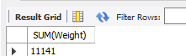

1. [SQL Week 1 Question 100-019] You are going to have a scene in which all the basilisks are on one side of a balance scale, and the single smallest dinosaur is on the other side of the scale. The dinosaur is bigger, of course. By how many pounds? (It’s OK if you need to run two separate queries and then manually subtract them.)

Sum weight of Basilisk = 5007 Select sum(weight) FROM masterpiece.litcharacters Where CreatureSubType= 'basilisk';

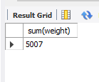

Smallest dinosaur weight = 7409 Select min(weight) FROM masterpiece.litcharacters Where CreatureSubType= 'dinosaur';

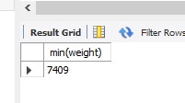

Math

Dinosaur – Basilisks

7409-5007 = **2402**

1. [SQL Week 1 Question 100-020] Use the LIKE command to select the idLitCharacters, name, and creature subtype of all the creatures which start with MER (i.e. mermen, mermaids, etc.). Sort it alphabetically by name.

SELECT idLitcharacters,name,creaturesubtype FROM masterpiece.litcharacters WHERE creaturesubtype LIKE 'Mer%' ORDER BY name ASC;

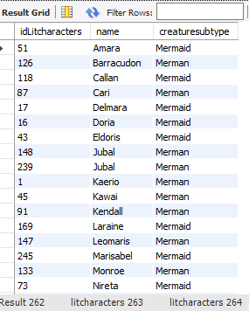

1. [SQL Week 1 Question 100-021] What is the average weight of all creatures for which the name contains the string ‘us’ ? The phrase can be anywhere in the name – so “Usman” would count, as would “Beusaleth” and “McManus.” (Your database may vary; these names may or may not be in your version of the database.) Note your answer to four decimal places.

Select avg(Weight) FROM masterpiece.litcharacters Where name like '%us%';

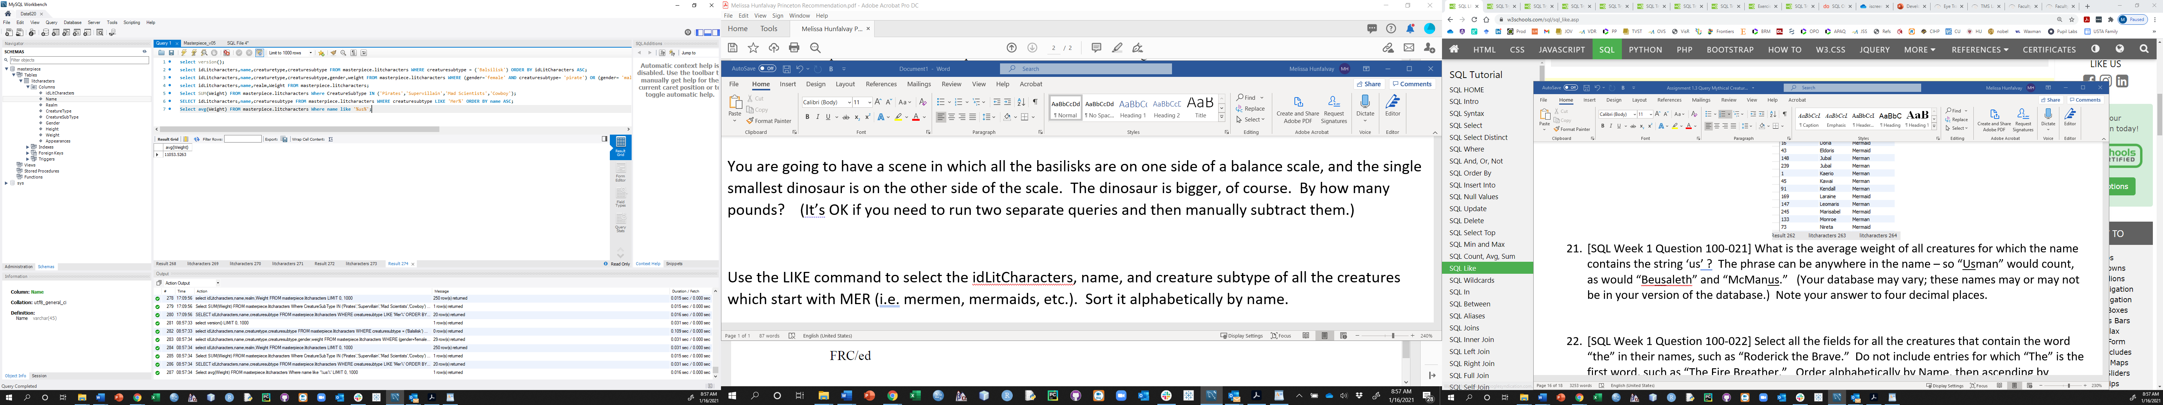

1. [SQL Week 1 Question 100-022] Select all the fields for all the creatures that contain the word “the” in their names, such as “Roderick the Brave.” Do not include entries for which “The” is the first word, such as “The Fire Breather.” Order alphabetically by Name, then ascending by idLitCharacters.

SELECT * FROM masterpiece.litcharacters Where name like '% the %' AND name not like 'the%' ORDER BY name, idLitCharacters ASC;

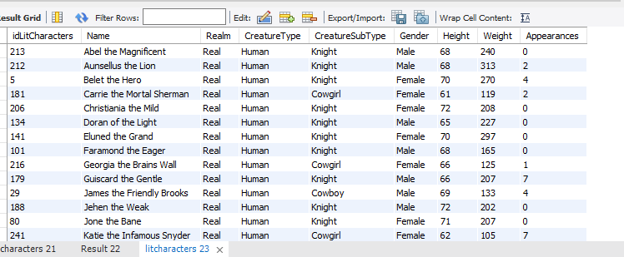

1. [SQL Week 1 Question 100-023] List all creatures which have two consecutive L’s anywhere in their name (such as “Elling” or “Llewers” or “Dingell”) and which are not Knights. Sort by number of appearances (fewest appearances on top) and then ascending by idLitCharacters.

SELECT idLitcharacters,name,creaturesubtype,Appearances FROM masterpiece.litcharacters Where name like '%ll%' AND creaturesubtype not like 'Knight' ORDER BY Appearances,idLitCharacters ASC;

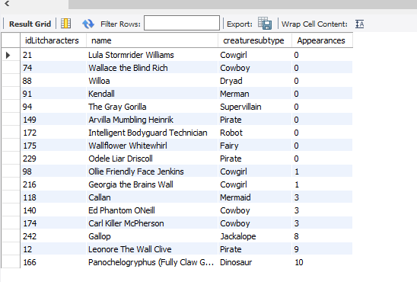

1. [SQL Week 1 Question 100-024] Use the SQL IN command to select all fields from all creatures which are Knights, Pirates, Fairies, or Jackalopes and who have had 1 or more appearances to date. Sort it by idLitCharacters, this time in DESCENDING order, so the highest ID is on the top. Use the SQL LIMIT command to display only 10 results.

SELECT idLitcharacters,creaturetype,creaturesubtype,Appearances FROM masterpiece.litcharacters Where Appearances>=1 AND creaturesubtype IN ('Knight','Pirate','Fairy','Jackalope') ORDER BY idLitCharacters DESC LIMIT 10;

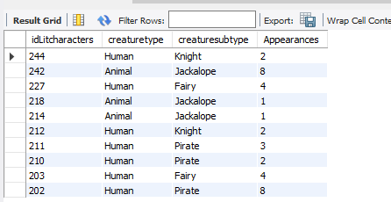

How many of each type were in your top 10 results?

Creature Type:

Human = 7

Animal = 3

Creature Subtype:

Knight = 2

Jackalope = 3

Fairy = 2

Pirate = 3

1. [SQL Week 1 Question 100-025] You want something small and cute. How many creatures have a height between 10 and 15 inches and a weight between 5 and 10 pounds? (Hint: you should use the BETWEEN command)

SELECT idLitCharacters,creaturetype,creaturesubtype,Height,Weight FROM masterpiece.litcharacters Where height BETWEEN 10 and 15 AND Weight BETWEEN 5 and 10;

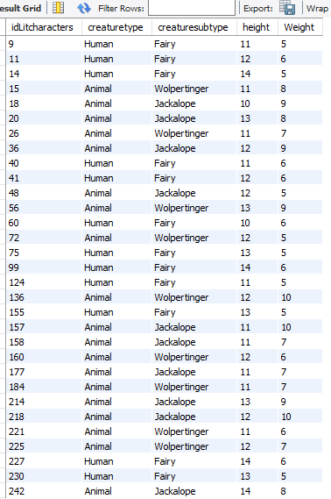

Select COUNT(creaturesubtype) FROM masterpiece.litcharacters Where height BETWEEN 10 and 15 AND Weight BETWEEN 5 and 10;

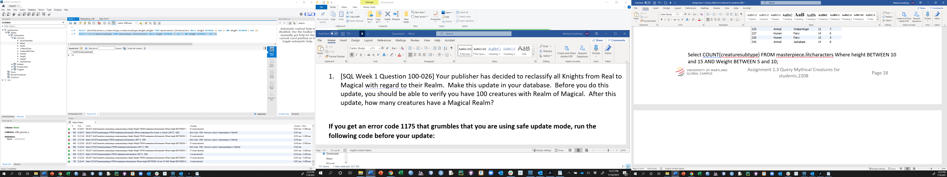

Total creatures = **31**

1. [SQL Week 1 Question 100-026] Your publisher has decided to reclassify all Knights from Real to Magical with regard to their Realm. Make this update in your database. Before you do this update, you should be able to verify you have 100 creatures with Realm of Magical. After this update, how many creatures have a Magical Realm?

**If you get an error code 1175 that grumbles that you are using safe update mode, run the following code before your update:**

**SET SQL_SAFE_UPDATES = 0;**

Note – this command has you modify the database. If you are then going to go back and answer some other questions after you do this command, be sure you refresh your database (i.e. re-load and re-run the script which made the database in the first place) before answering those questions.

SELECT COUNT(Realm) FROM masterpiece.litcharacters Where Realm= 'magical';

Verify you have 100 creatures with Realm of Magical:

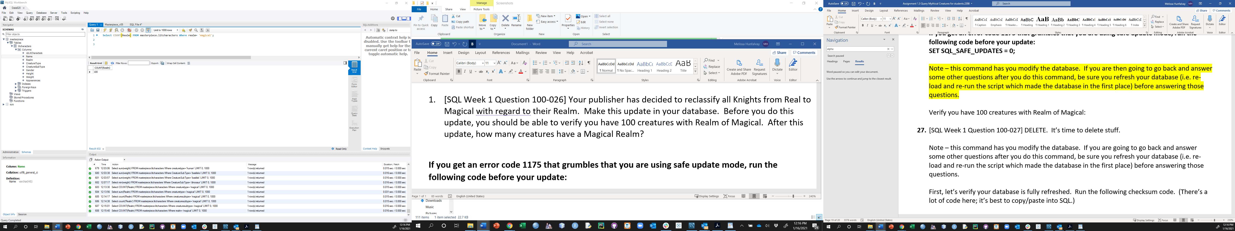

SET SQL_SAFE_UPDATES = 0;

UPDATE masterpiece.litcharacters SET Realm= 'Real', Realm= 'Magical' Where creaturesubtype= 'Knight';

SELECT COUNT(Realm) FROM masterpiece.litcharacters Where Realm= 'magical';

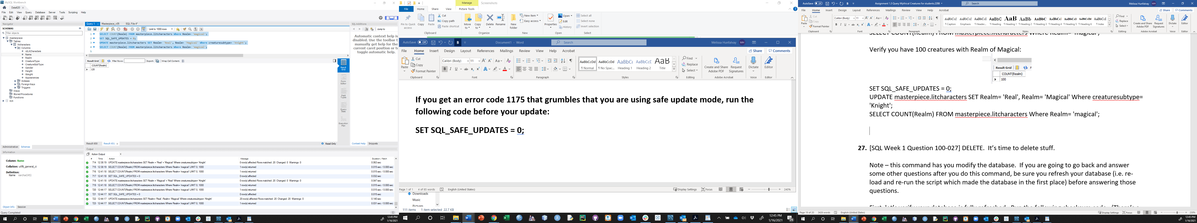

Creatures = **120**

1. [SQL Week 1 Question 100-027] DELETE. It’s time to delete stuff.

Note – this command has you modify the database. If you are going to go back and answer some other questions after you do this command, be sure you refresh your database (i.e. re-load and re-run the script which made the database in the first place) before answering those questions.

First, let’s verify your database is fully refreshed. Run the following checksum code. (There’s a lot of code here; it’s best to copy/paste into SQL.)

**SELECT ((COUNT(*) * AVG(Weight)) MOD 99) as checksum from litcharacters;**

**You should get a checksum answer of 47.**

**NOTE: I had to reload the database here, then I got 47.**

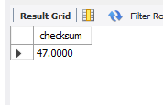

Delete all the dinosaurs who have already made an appearance. In other words, delete anything with a Creature SubType of Dinosaur and more than 0 appearances.

Run the checksum code again. What is your checksum now? **86**

SET SQL_SAFE_UPDATES = 0;

DELETE FROM litcharacters Where not Appearances=0 AND creaturesubtype= 'Dinosaur';

1. [SQL Week 1 Question 100-028] Note – this command has you modify the database. If you are going to go back and answer some other questions after you do this command, be sure you refresh your database (i.e. re-load and re-run the script which made the database in the first place) before answering those questions.

First, check your database is fully refreshed. Run the following checksum code. (There’s a lot of code here; it’s best to copy/paste into SQL.)

**SELECT ((COUNT(*) * AVG(Weight)) MOD 99) as checksum from litcharacters;**

**You should get a checksum answer of 47.**

**NOTE: I had to reload the database here, then I got 47.**



You have some more characters to include. Insert the below characters in to the database:

('Mogwai', 'Magical', 'Other', 'Fairy', 'Female', '25', '158','2'),

('Menehune', 'Real', 'Human', 'Superhero', 'Male', '56', '195','5')

SELECT version();

SELECT ((COUNT(*) * AVG(Weight)) MOD 99) as checksum from litcharacters;

SET SQL_SAFE_UPDATES = 0;

INSERT INTO litcharacters (`Name`, `Realm`, `CreatureType`, `CreatureSubType`, `Gender`, `Height`, `Weight`,`Appearances`) VALUES ('Mogwai', 'Magical', 'Other', 'Fairy', 'Female', '25', '158','2'),('Menehune', 'Real', 'Human', 'Superhero', 'Male', '56', '195','5');

SELECT ((COUNT(*) * AVG(Weight)) MOD 99) as checksum from litcharacters;

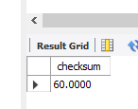

**Now what is your checksum? 60**